**Du arbejder på et stort hospitalsvaskeri og I har besøg af en udenlandsk gruppe.**

**De vil gerne vide mere om jeres arbejdsmiljø.**

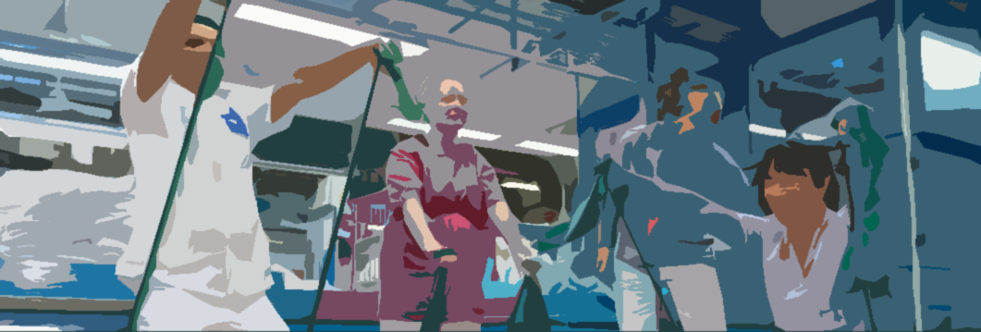

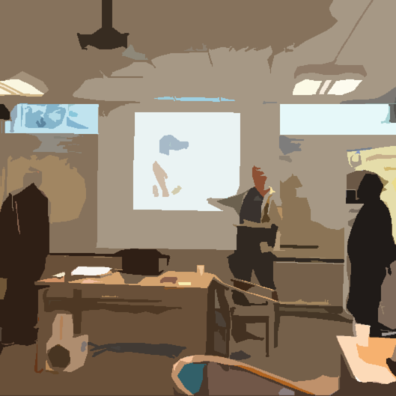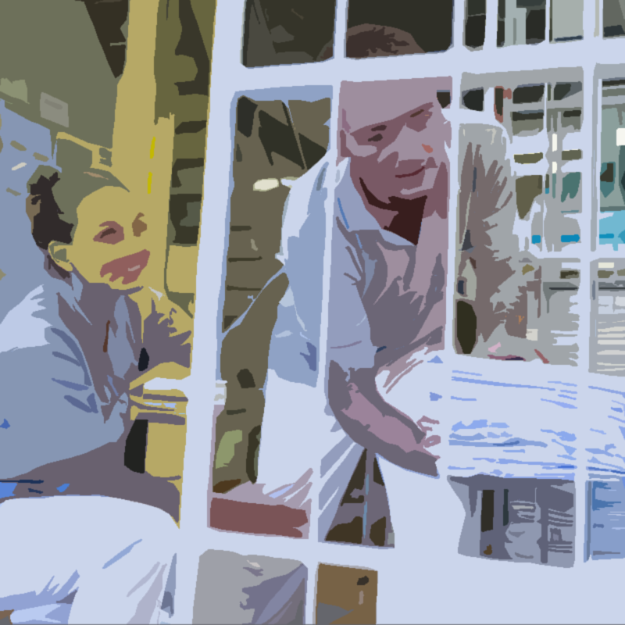



*Læs direktivet, og udfør opgaverne i* Task 1 *og* Task 2*.*

**Beskrivelse af sundheden på vaskeriet**

|  |
| --- |
| **All our health work must make sense and be targeted.**  **The goal is: We must become healthier by working at midtVask.**  When we work with health at midtVask, it is based on the fact that we look at each other as whole people who have both a private life and a working life. And that it is therefore not just about carrots and exercise, but about our mental, social and physical health.  When they start at midtVask, all new employees are introduced to our goals and the health strategy, and which of activities we offer at midtVask. In this way, we ensure through dialogue that everyone from the beginning has knowledge of the background of the health work and thereby also has the opportunity to act in relation to their own and their colleagues' health.  In the physical area, good health means for us that we want less pain, fewer work accidents and low sickness absence. We must stay healthy and strong throughout our working lives and more. Therefore, we prioritize that we must become stronger and get in better shape. We achieve this by knowing the healthy choices, by knowing what good ergonomics are and how the body works, and by participating in elastic training every time and taking care of our own health and participation.  Our social health is very much related to the fact that we believe in ourselves and enter into meaningful and healthy relationships at work. Learning and development take place in a social context, and the social relations between each person at a workstation are of the utmost importance. Good structures and collaborative relationships are important to build. Clear goals that one can work towards and common workplace values contribute to our social health. Our well-being and low sickness absence can be measured and felt, team organization and whiteboard meetings promote dialogue and cooperation, just as social activities are given a high priority.  Our mental health is improved when we can each unfold our abilities and deal with everyday challenges and stress, so that we can positively and fruitfully work productively and make our contribution to the community. That is why it is important that we constantly develop and learn new things, which is why midtVask gives a high priority to competence development and education. |
| **Oversat tekst fra https://midtvask.dk/arbejdsmiljoe-og-sundhed/** |

**TASK 1**

*Svar på spørgsmålene.*

|  |  |  |
| --- | --- | --- |
| 1 | Why do we work with our health at midtVask? |  |
| 2 | What do we want from good physical health for our employees? |  |
| 3 | How do we take care of our physical health at midtVask? Write 2 examples. |  |
| 4 | Why is it important for us to work with our social health? |  |
| 5 | What do we do for our mental health at midtVask? |  |

**TASK 2**

*Er udtalelserne sande eller falske? Sæt kryds i den rigtige kasse.*

|  |  |  |  |
| --- | --- | --- | --- |
|  |  | Answer | |
|  |  | True | False |
| 1 | We must become healthier by working at midtVask. |  |  |
| 2 | Health is just about carrots and exercise. |  |  |
| 3 | We want more pain, more work accidents and high sickness absence. |  |  |
| 4 | We must become stronger and get in better shape. |  |  |
| 5 | Learning and development take place in a social context. |  |  |
| 6 | Good structures and collaborative relationships are important to build. |  |  |
| 7 | Our well-being and low sickness absence can be measured. |  |  |
| 8 | It is important that we do not develop and learn new things, |  |  |

Samtaletest trin 3-4

**Talk with your teacher**

How do you take care of your physical and social health?

* For example: Are there possibilities at your work?
* Or tell about some activities you do in your spare time.

Skrivetest trin 3-4

Write an e-mail to your superior at work where you suggest activities you think will promote health and cooperation at the job. (You may use the photos on p. 1 as inspiration)